:Step By Step GLPI Installation Guide for Linux:
Requirements
1) Working Apache server
2) Working Mysql Server
3) Latest version of GLPI
Step by Step Installation
1) Mysql configuration
Login to mysql server through shell (or webmin). Create database glpidb
db name - glpidb, username - glpiuser , password - glpipwd

#mysql -u root -p ( enter the mysql root password)
mysql> create database glpidb;
mysql> grant all privileges on glpidb.* to glpiuser@localhost identified by 'glpipwd';
mysql> exit
If you are ruining apache and mysql in different servers, you have to use glpiuser@apacheserverip
2)GLPI installation
Login to apache server host through shell
Download the latest glpi archive
Un tar glpi-0.72.4.tar.gz in the web root directory
#tar -xvzf glpi-0.72.4.tar.gz -C /var/www/html/
#cd /var/www/html
#chown -R apache glpi
Add dns engry for your support website ( support.example.com to 192.168.1.2 (replace with your ip) )
If you don't have dns server, you can use the ip directly
edit /etc/httpd/conf/httpd.conf and add the following configurations

< VirtualHost 192.168.1.2:* >
DocumentRoot /var/www/html/glpi
ServerName support.example.com
RewriteEngine on
RewriteCond %{REQUEST_METHOD} ^(TRACE|TRACK)
RewriteRule .* - [F]
< Directory "/var/www/html/glpi" >
DirectoryIndex index.php
< /Directory >
Options ExecCGI
< /VirtualHost >
Or add alias for this glpi directory
Restart apache server

#service httpd restart

Browse your support url http://support.example.com or ip (from remote computer)
for directory access use http://192.168.1.2/glpi ( from local host http://localhost/glpi)

Click on “OK”

Click on “Installation”
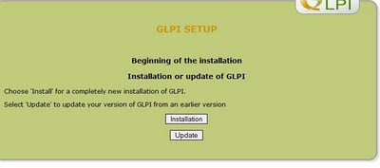
Click on “Continue” button

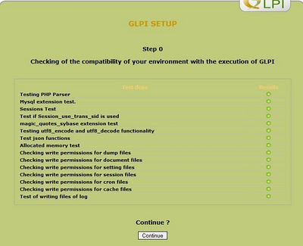
Enter the db server name, user and password which we created in previous step.
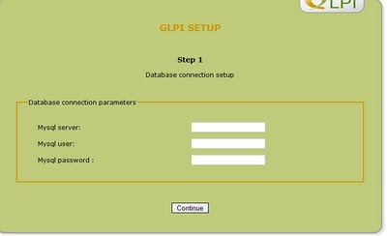
Enter the Mysql user name password details and continue
host - mysqlserverip (localhost)
User Name= glpiuser
Password = glpipwd
Select the database glpi form the shown list and continue
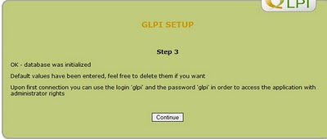
Click on “use GLPI”
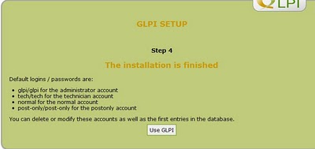
Admin user name - glpi , password - glpi
